1D Motion Platform
Software Guide

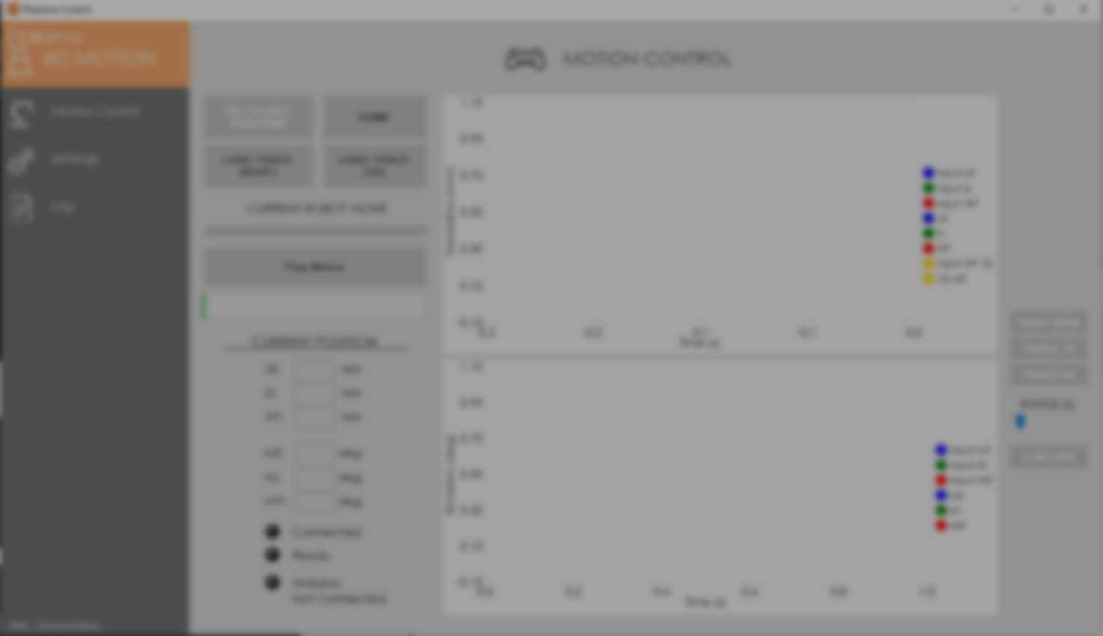

Software Guide
Uploading the Arduino Code to Uno 3
The first part of setting up the 1D motion platform software is to upload the Arduino IDE code, which can be found here. Ensure Arduino IDE is installed onto your PC; you can find the link to install IDE here. Once installed, open the code and ensure your Arduino Uno 3 is connected to your PC, then click on the arrow to upload the code. Once successfully uploaded, we can move onto the Phantom Control Program.

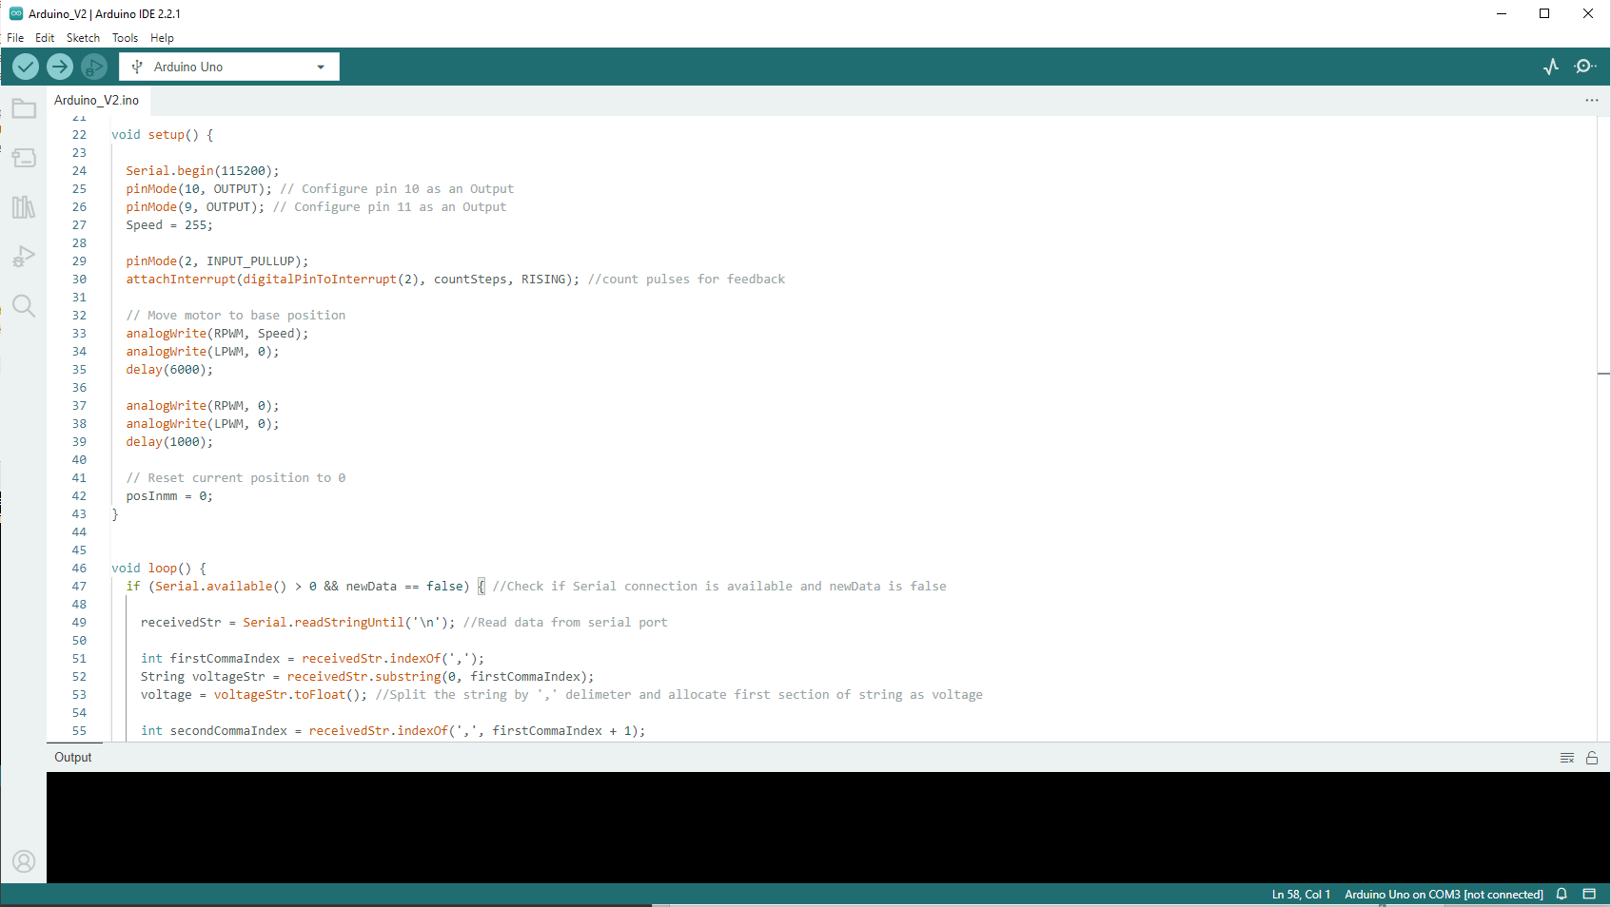

Software Guide
Connecting, Homing, Loading and Running Trace
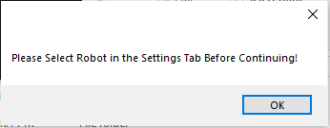
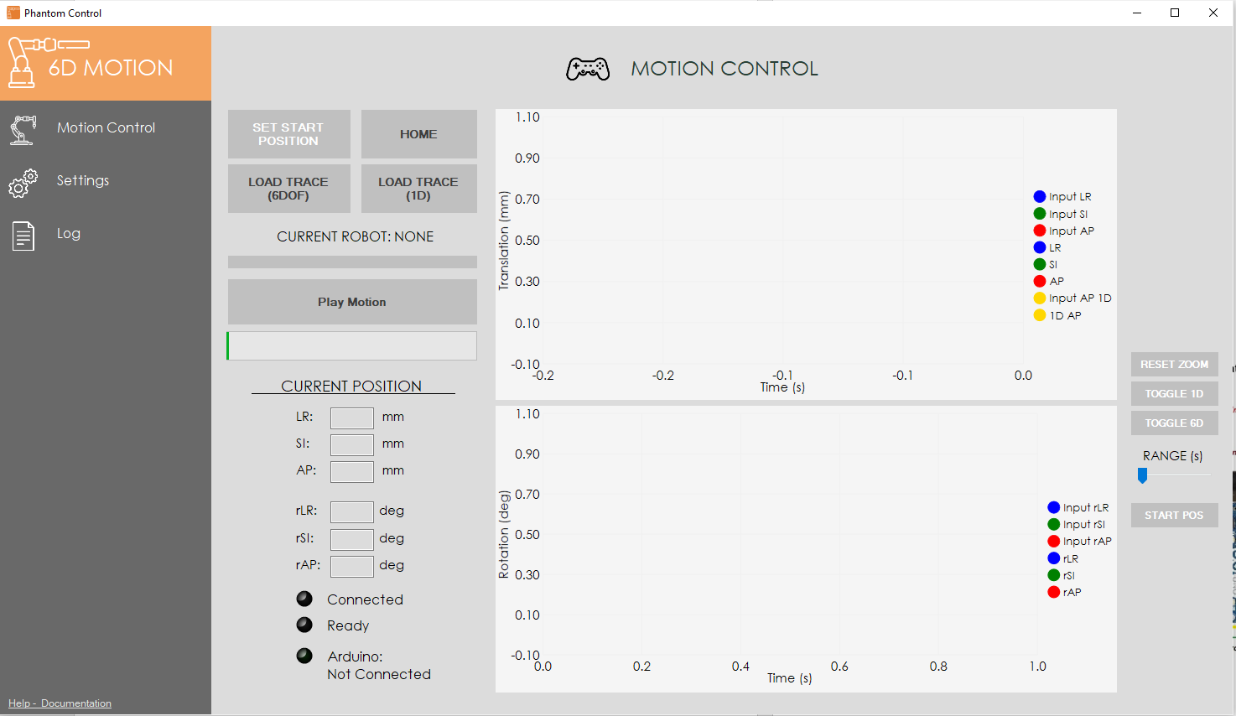
This pop-up dialog will appear on the screen, prompting the user to select which robot they would like to control. As shown in the image above, click on the settings tab and look for this selection. Then go back to Motion Control and press SET START POSITION. This will update all the selectable/interactable buttons according to your selection.
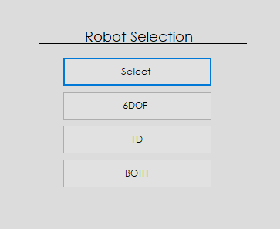

Software Guide
For example, I selected 1D in the settings tab, if the Arduino is connected properly, and I press SET START POS, my screen should look like this.
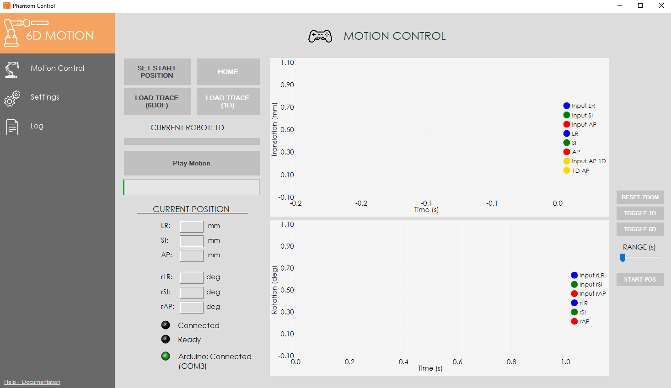

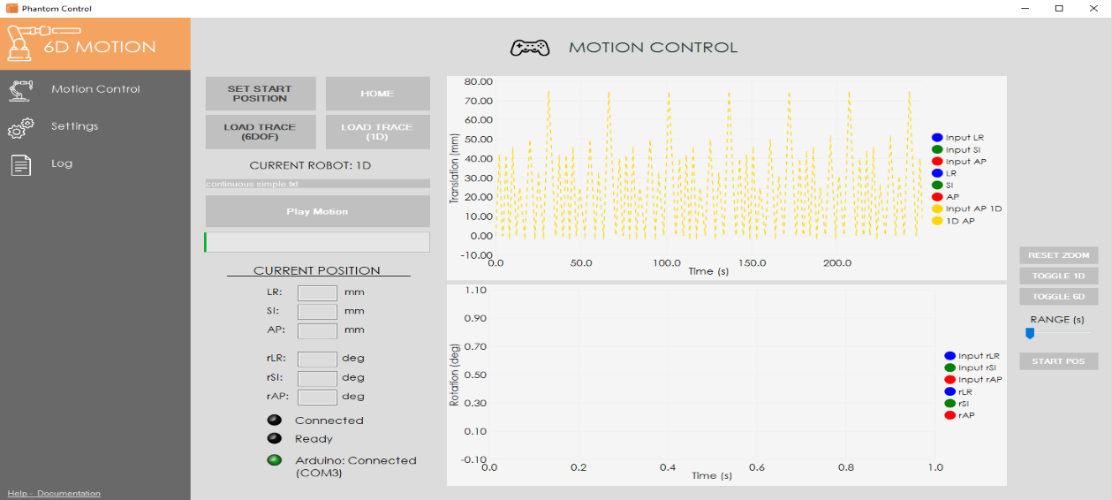
As you can see in the image above, the HOME and LOAD TRACE (1D) buttons become interactable, while LOAD TRACE (6D) is still disabled, as we only selected the 1D robot. The UI current robot status will update and a green LED lights up as a visual confirmation of connectivity. From here, it will allow the user to select and upload the motion trace which will update the charts on the right-hand side of the screen and then allow the user to play the motion trace file.

Software Guide
Chart Controls – Zooming & Panning
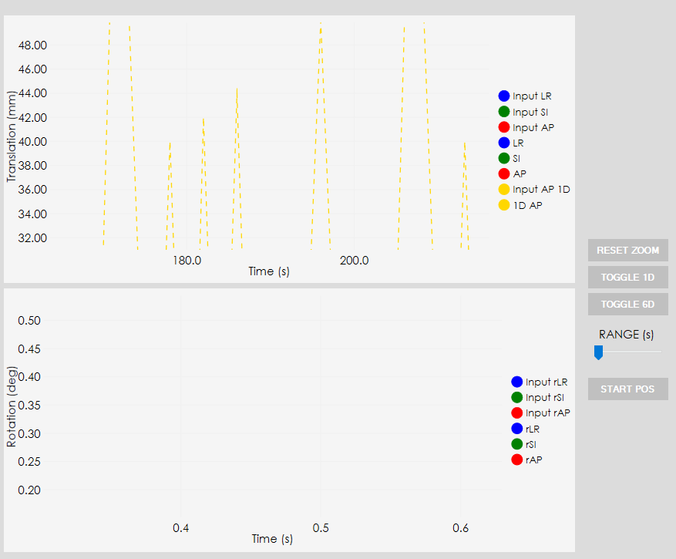
To the very right-hand side of the screen is a panel that provides the user with some controls. Due to feedback regarding the previous version of the software, there was a request to implement chart controls, especially since there will be plotting of both 1D and 6DOF inputs and outputs, which will lead to visual clutter in the chart space.
Figure 1 - Zoomed Plot
Figure 2 - Zoomed Plot using mouse control
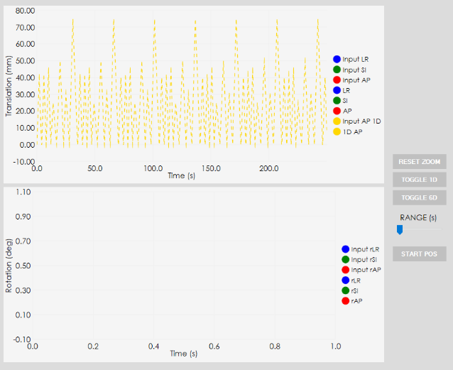
This newer version of the software allows the user to pan around the plot, zoom in/out using their mouse (scroll wheel to zoom in/out and click-drag to pan). This will enable the user to zoom into a specific part of the plot, which can be useful when trying to explore an area of interest, while real time positional feedback from the robots is being plotted.
Figure 1 - Normal Plot

Additionally, the range slider allows the user to adjust the timeframe of the x-axis plot. For example, if the 6DOF trace is being played and the feedback is being plotted real time, the range slider can be adjusted so that it is always a certain time window (e.g. 10 seconds) visible, meaning the current time and x seconds before. This will help with visual clutter while running traces, allowing the user to be flexible with the plotting range and to differentiate between the two robot motion plots.

Software Guide
Chart Controls – Range Adjustment

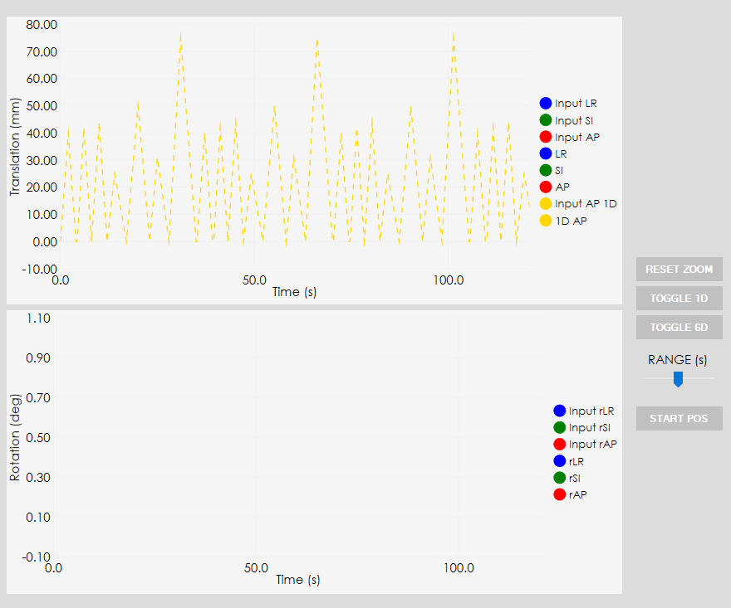
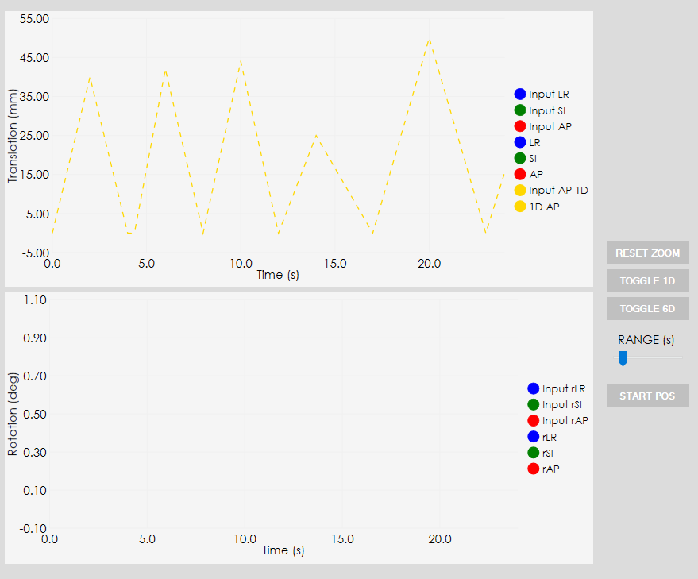
Figure 3 - Range adjusted to 130s
Figure 4 - Range adjusted to 25s

Software Guide
Chart Controls – Series Toggling
The Chart controls also allow for toggling between the 6DOF and 1DOF plots. This is useful as it provides the user to choose what plots they want to have visible on the screen.
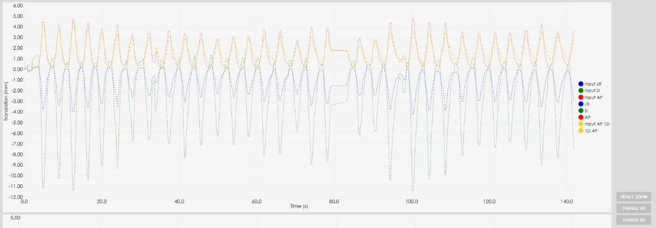
TOGGLE BOTH
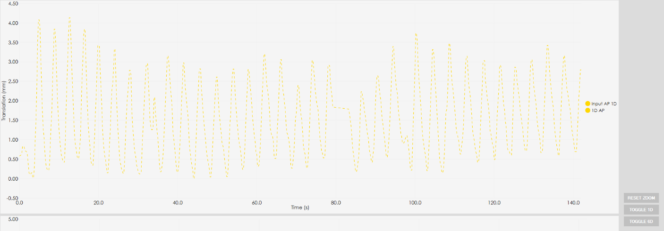
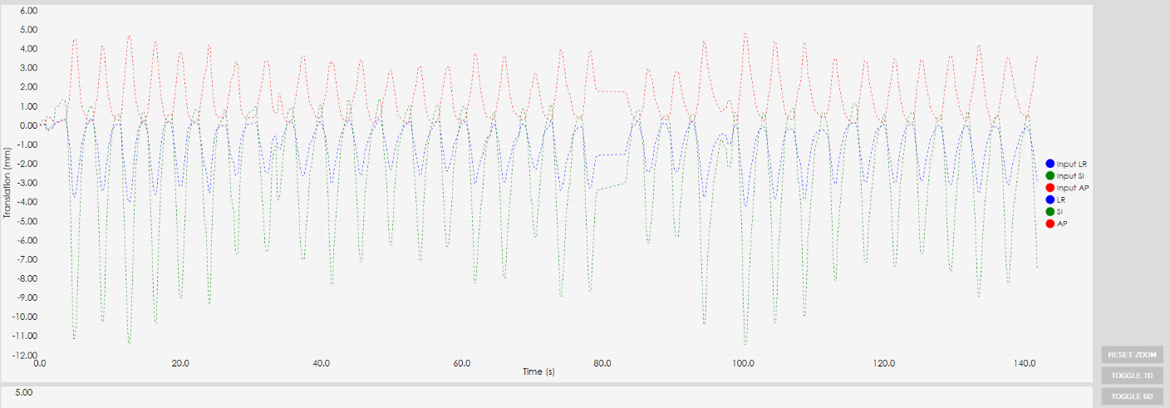
TOGGLE 1D
TOGGLE 6DOF

